Technical Design Document
Medical Device Rental and Inventory Management System
Prepared for: Mahesh Foundation
Date: 06/04/2026
This document presents architectural flow & two tech stack approaches for the proposed system,
with detailed resource breakdown, pros & cons, and annual cost estimates
on Azure to support an informed decision.

1. Executive Summary

This document outlines two architectural options for building the Medical Device Rental & Inventory Management System for Mahesh Foundation. Each approach has been evaluated against the requirements in the Business Requirements Document (BRD), with considerations for scalability, cost, ease of build, and long-term maintainability. Both options are assessed with Azure as the hosting platform.
.

Option | Description | Best Suited For
Option A | WordPress + Plugin Ecosystem + Integrations | Teams preferring a familiar CMS platform
Option B | Lovable (Next.js) + Supabase — Modern Custom Build | Scalable, mobile-ready

2. System Overview

The Medical Device Rental & Inventory Management System will serve the following primary functions:

- Centralized asset and inventory management across multiple centers
- End-to-end lease lifecycle management — request, approval, issuance, return
- Repair and warranty tracking
- Role-based access for Admin, Center Admin, and Approver roles
- Automated SMS notifications via MSG91 for all workflow triggers
- QR / barcode-based device identification and scanning
- Dashboards, reports, and utilization analytics
- Public-facing lease request portal for requestors — no login required
User Roles
Role | Access Level | Key Functions
Admin | Full system access | All functions including user management and reports
Center Admin | Center-level access | Inventory, issuance, returns, asset transfers
Approver | Approval workflows only | Review and approve or reject lease requests
Public | No login required | Submit lease requests and track status via token

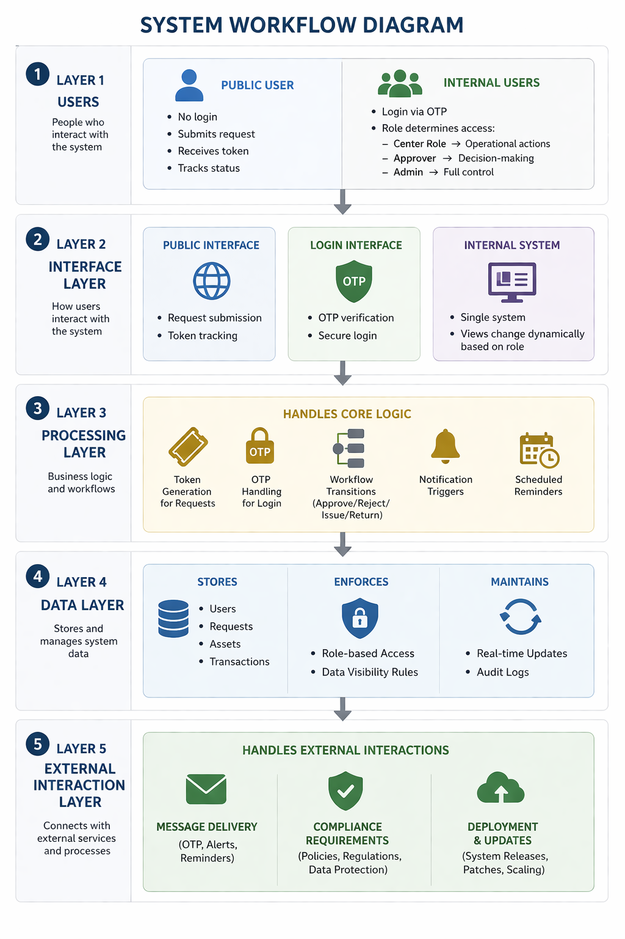

Layer-by-Layer Workflow (Clean Version)
Layer 1 — Users
- Public User
  - No login
  - Submits request
  - Receives token
  - Tracks status
- Internal Users
  - Login via OTP
  - Role determines access:
    - Center role → operational actions (issuance, returns, asset transfer)
    - Approver → decision-making (review- approve/reject – add comments)
    - Admin → full control

Layer 2 — Interface Layer
- Public interface:
  - SKU Catalog
  - Request submission
  - Token tracking
- Login interface:
  - OTP verification
- Internal system:
  - Single system
  - Views change dynamically based on role

Layer 3 — Processing Layer
Handles core logic:
- Token generation for requests
- OTP handling for login
- Workflow transitions (approve/reject/issue/return)
- Notification triggers
- Scheduled reminders

Layer 4 — Data Layer
- Stores:
  - Users
  - Requests
  - Assets
  - Transactions
- Enforces:
  - Role-based access
  - Data visibility rules
- Maintains:
  - Real-time updates
  - Audit logs

Layer 5 — External Interaction Layer
- Handles:
  - Message delivery (OTP, alerts, reminders)
  - Compliance requirements
  - Deployment & updates

3. Suggested Tech Stacks:
(3.a) Option A — WordPress + Integrations

WordPress is used as the core platform, with custom plugins and third-party integrations handling workflow, SMS, and QR functionality. This is a familiar platform but carries significant overhead for a workflow-driven application of this nature.

Technology Stack

Layer | Technology | Purpose
Frontend & Backend | WordPress (PHP) | Core platform, UI, admin panel
Database | Azure MySQL Flexible Server | All data storage
Forms & Workflow | Gravity Forms + custom PHP | Lease requests, approval flows
Custom Data | Advanced Custom Fields (ACF Pro) | Asset fields, serial numbers, warranty details
User Roles | User Role Editor Plugin | Role-based access control
SMS | MSG91 via REST API | All notification and reminder triggers
QR Scanning | html5-qrcode JS library | Browser-based barcode scanning
Scheduled Jobs | Server-side cron (not WP-Cron) | Return reminders and overdue alerts
Hosting | Azure App Service + Azure MySQL | Production environment on Azure

What WordPress Handles Well vs. What It Struggles With
Handles Well (60–70%) | Requires Heavy Custom Work (30–40%)
✓ Asset and inventory management via custom post types | ✗ Complex multi-stage workflows require custom state management and are not natively supported
✓ Basic user roles and access control | ✗ Time-critical scheduling requires external cron; built-in scheduling is traffic-dependent and unreliable
✓ Form-based lease request submission | ✗ Real-time data synchronization is not natively supported and requires external mechanisms
✓ Basic dashboards and tabular reports | ✗ Advanced device integrations (camera scanning, hardware access) require custom frontend handling
✓ Return logging and status update forms | ✗ Secure identity verification flows (e.g., Aadhaar) require external integrations and compliance handling  Token generation is simple, but enforcing uniqueness and traceability at scale requires structured logic
Pros & Cons
Advantages | Disadvantages
✓ Widely known platform — easy to find developers | ✗ Heavier architecture compared to custom-built systems — performance overhead at scale
✓ Large plugin ecosystem reduces initial build time | ✗ Dependency on plugins — updates can introduce instability or conflicts
✓ Familiar admin UI for non-technical users | ✗ Not inherently designed for workflow-driven or stateful applications
✓ Many hosting providers support it natively on Azure | ✗ Mobile app expansion requires rebuilding core logic in a different stack
✓ Fast time-to-market for MVP and internal tools | ✗ Increasing costs over time due to plugin licenses and scaling infrastructure
✓ Strong community support and documentation | ✗ Higher long-term maintenance effort as dependencies and customizations grow

Annual Cost Estimate — Option A on Azure

Service | Specification | Monthly (INR) | Annual (INR)
Azure App Service (South India) | B2 tier — 2 cores, 3.5GB RAM | ₹10,380.737 | ₹1,24,569(approx)
Azure MySQL Flexible Server | Burstable B1MS | ₹ 1,695.521 | ₹20,347 (approx)
Azure Blob Storage | 100GB for media and assets | ₹227 | ₹2730
Azure Front Door Standard (CDN)  (Required only if the public usage scale is large, can be integrated in phase two) | Standard tier (CDN Classic retired Sep 2027) | ₹3318.044(base)  ₹1033(100gb data usage) | ₹52,300(approx.)  (range may vary based on data usage)
Plugin Licences | Gravity Forms(pro) + ACF Pro + WP Rocket | 13000/year  +4000/year+  5000/year | ₹22000
MSG91 SMS | ~750 SMS/month @ ₹0.25/SMS | ₹188-200 | ₹2,250
Domain + DLT Registration | Annual + one-time | — | ₹2,500
TOTAL YEAR 1 |  |  | ₹2,26,696
(B2 gives us better control over data and workflows by reducing plugin dependency and separating concerns, which makes the system more maintainable and easier to scale compared to a tightly coupled B1 setup)
(These plugins i.e. Gravity forms, ACF pro, WP rocket are required to turn WordPress from a basic CMS into a structured, workflow-driven application with acceptable performance.)

(3.b) Option B — Lovable (Next.js) + Supabase

A fully custom modern web application built using AI-assisted development (vibe coding) with Lovable as the primary build tool and Supabase as the backend-as-a-service platform. The frontend is hosted on Azure Static Web Apps while Supabase provides a managed, enterprise-grade PostgreSQL backend.
Technology Stack
Layer | Technology | Purpose
Frontend | Next.js + Tailwind CSS + shadcn/ui | Web application UI — all screens
Build Tool | Lovable.dev + Cursor AI | Assisted development tools used to accelerate UI and logic generation
Database | Supabase — PostgreSQL | All structured data — assets, leases, users, returns
Authentication | Supabase Auth — OTP/mobile | OTP login for all internal roles — no passwords
File Storage | Supabase Storage | Asset images, invoice documents, QR codes
Business Logic | Supabase Edge Functions | SMS triggers, token generation, cron jobs
Real-time Sync | Supabase Realtime | Near real-time updates for inventory changes across users
SMS | MSG91 REST API | All notification workflows — approvals, reminders, returns
QR Scanning | ZXing.js or Bluetooth scanner | Device identification on issuance and return
Frontend Hosting | Azure Static Web Apps | Production deployment on Azure
Future Mobile | React Native + Expo | Phase 2 mobile app — same codebase, no rebuild

Pros & Cons
Advantages | Disadvantages
✓ Lowest annual cost — less than half of Option A | ✗ Hybrid cloud setup if other infrastructure is hosted on a different provider
✓ Modern, fast, scalable architecture | ✗ Learning curve for the team (modern frameworks and backend services)
✓ Real-time inventory sync built into Supabase | ✗ Requires engineering effort for custom workflows and integrations
✓ OTP authentication built in — no additional plugin | ✗ Yearly Costs vary based on the usage
✓ Mobile app in Phase 2 extends naturally — no rebuild | ✗ External messaging services (SMS) incur per-message charges that scale with usage
✓ Clean codebase — no plugin dependency risk | ✗ Vendor dependency — pricing or policy changes can impact long-term costs

Annual Cost Estimate — Option B on Azure
Service | Specification | Monthly (INR) | Annual (INR)
Azure Static Web Apps | Standard tier — $9/month | ₹853.212 | ₹10,236
Supabase Pro | PostgreSQL + Auth + Storage + Edge Functions — $25/month | ₹2,318  (may vary based on usage) | ₹27,816
MSG91 SMS | ~750 SMS/month @ ₹0.25/SMS | ₹188 | ₹2,250
Variable Costs(Supabase x Azure Hybrid) |  | ₹500-₹2000 | ₹18000
Domain + DLT Registration | Annual + one-time | — | ₹2,500
TOTAL YEAR 1 |  |  | ₹60,802
(While this approach introduces usage-based costs and requires stronger engineering ownership, it provides significantly better control, scalability, and long-term flexibility)

5. Option B — Side by Side Comparision

Factor | Option A — WordPress | Option B — Modern Stack
Annual Cost on Azure | ₹2,26,696 (largely fixed) | ₹60,802 baseline + usage-based scaling
Estimated Build Time | 10–14 weeks | 4-6 Weeks
Coding Required | Medium to High (custom PHP + plugins) | Low to Medium (assisted development + structured backend)
Performance | Moderate — plugin and theme overhead | High — lightweight, optimized architecture
Real-time Inventory Sync | Not native — requires workarounds | Built-in real-time capability
OTP Authentication | Plugin-dependent | Native support within auth system
Mobile App (Phase 2) | Requires separate backend or rebuild | Can reuse existing backend with minimal changes
Enterprise Readiness | Depends on plugin quality and setup | Backed by platform-level compliance standards
Long-term Maintenance | Plugin updates and compatibility risks | Lower dependency surface, but requires engineering ownership
Scalability | Suitable for moderate scale, may require re-architecture later | Designed to scale with increasing usage (cost scales accordingly)
(Option A is suitable for faster initial deployment with predictable costs, while Option B is better aligned with the system’s long-term needs, including scalability, real-time operations, and future mobile expansion)

🧩 Supabase’s Role in Your System (Option B)
Think of Supabase as your entire backend layer.

🗄️ 1. Database (Core System Data)
What it handles:
- Users
- Assets (devices)
- Lease requests
- Transactions (issue/return)
- Warranty & repair logs
👉 This is your single source of truth

🔐 2. Authentication (OTP Login System)
What it handles:
- Sending OTP (via integration)
- Verifying OTP
- Creating user sessions
- Assigning roles
In your system:
- Center Admin logs in → OTP
- Approver logs in → OTP
- Admin logs in → OTP
👉 No passwords needed

🧠 3. Role-Based Access Control
What it handles:
- Who can see what
- Who can edit what
Example:
- Center Admin → only their center’s assets
- Approver → only approval requests
- Admin → full access
👉 Enforced at data level (not just UI)

⚙️ 4. Business Logic (Edge Functions)
What it handles:
- Token generation (MF-YYYY-NNNN)
- SMS triggers
- Workflow transitions
- Scheduled jobs (reminders)
Example:
- Request submitted → generate token → send SMS
- Approval → trigger notification
- Daily → check overdue returns
👉 This replaces:
- custom backend server
- cron jobs

📡 5. Real-time Sync
What it handles:
- Live updates across users
Example:
- Asset issued → instantly updates everywhere
- Return logged → dashboards update
👉 No manual refresh needed

📁 6. File Storage
What it handles:
- Asset images
- Invoice documents
- QR codes
👉 Secure + scalable storage

🔔 7. Event Handling + Triggers
What it handles:
- Actions → reactions
Example:
- New request → trigger SMS
- Status change → notify user
- Return overdue → send reminder
👉 Works like a workflow engine

🔍 8. API Layer (Auto-Generated)
What it handles:
- All frontend ↔ backend communication
Example:
- Fetch assets
- Submit request
- Update status
👉 You don’t build APIs manually

🧾 9. Audit & Logging (Implicit)
What it enables:
- Track:
  - who did what
  - when
👉 Important for:
- accountability
- debugging

🧱 10. Scalability Layer
What it handles:
- Growing users
- Increasing data
- More requests
👉 No infra management needed

🧠 Simple Mental Model
Supabase replaces:
Traditional System | Supabase
Backend server | ✅
Database | ✅
Auth system | ✅
API layer | ✅
Realtime engine | ✅
Storage system | ✅
Cron jobs | ✅

🔥 One-Line Summary (Use This)
“Supabase handles the entire backend — including database, authentication, business logic, real-time updates, storage, and APIs — eliminating the need for a custom server.”

